TYPE YOUR TITLE HERE AND APPLY THE APPROPRIATE TITLE STYLE. STYLE NAMES ARE: “TITLE ONE-LINE” ETC

A Thesis
Presented to the
Faculty of
San Diego State University

In Partial Fulfillment
of the Requirements for the Degree
Type of Degree, e.g., Master of Arts
"in", "of", or "and"
Name of Degree, e.g. Education

by
Type Your Name Here--See Manual For Instructions
Term Completed: Fall, Spring,Or Summer year

SAN DIEGO STATE UNIVERSITY
The Undersigned Faculty Committee Approves the
Thesis of Type Your Name Here--see manual for help:
Type in Title of Thesis Here with Headline Style Capitalizaton

Type in Faculty Name (no DR or PhD), Chair
Type in Name of Department or School

Type in Faculty Name (no DR or PHD)
Type in Name of Department or School

Type in Faculty Name (no DR or PHD)
Type in Name of Department or School

Fourth Member, if needed
Type in Name of Department or School

Approval Date
Copyright © Year
by
Type Your Name Here--See Manual For Instructions
All Rights Reserved

dedication
Insert your dedication text here. The text on this page may be aligned like regular text (as done in this example) or it may be centered. When centering, the text should be centered both horizontally and vertically on the page (but the title must stay where it is now). See the Dissertation and Thesis Manual for instructions and examples.
Insert you epigraph here if you have one, or delete this page plus the following section break.

ABSTRACT OF THE THESIS
Type in your Thesis Title Here in Headline Style (like this text)
by
Your Name as it Appears on the Title Page
Your Degree as it Appears on the 3 Lines of the Title Page but Run Together here
San Diego State University, Year

Type in your abstract here using the “Single-spaced Text” Style. Indent paragraphs with one tab space; do not insert a blank line between paragraphs.

TABLE OF CONTENTS
PAGE
ABSTRACT #
LIST OF TABLES #
LIST OF FIGURES #
ACKNOWLEDGEMENTS #
CHAPTER
- introduction 3
references 3
- TITLE OF APPENDIX 3

READ THE “Template User Guide” file instructions about inserting page numbers for the preliminary pages and adding the APPENDIX column heading – both things you must do manually after generating the Table of Contents. Also, don’t forget to delete these instructions!
list of tables
PAGE
Table 1. Sample of a One-Row Table 3

list of figures
PAGE
Figure 1. SDSU photomontage. 3
Figure 2. SDSU thesis template styles. Note: The style “Title 2-line” is “boxed” only because the title on the title page was selected at the time this screen shot was taken. 3

acknowledgements
Insert your acknowledgements text here (except for students in Biology who will place this section after the text and before the reference list).

chapter 1
introduction
***If you haven't done so already, read the SDSU Dissertation and Thesis Manual (DTM) and the Template User Guide before continuing any further.***

***********
If you have already written/partially written your thesis—congratulations—most of the hard work is done! Now all you need to do is read pages 1-3 in this template document and follow the instructions in the DTM and Template User Guide —VERY MPORTANT.
Figure 1 and Figure 2 in this document show examples of figures so that the “List of Figures” page could be formatted properly for you. The same is true for Table 1. The thesis template styles that are shown in Figure 2 have been updated and the current list is given in the Template User Guide.
Pages are provided in this template for the post-text sections, i.e., References and Appendix cover sheet if you have appendices, just as they are for the pre-text sections above. Two pages formatted in LANDSCAPE orientation (including correct placement of the page numbers) are also provided, but in a separate template document (SDSU Template Landscape Pages).
FOOTNOTES for source documentation or explanation can easily be inserted by selecting INSERT/Reference/Footnote. The style has been programmed for the most-often used departmental style guides plus SDSU preferences. NOTE: M.S. Word sometimes incorrectly places a footnote one page after its first reference. You will notice when this happens because there will be a long separator line followed by the complete footnote. To fix

Figure 1. SDSU photomontage.

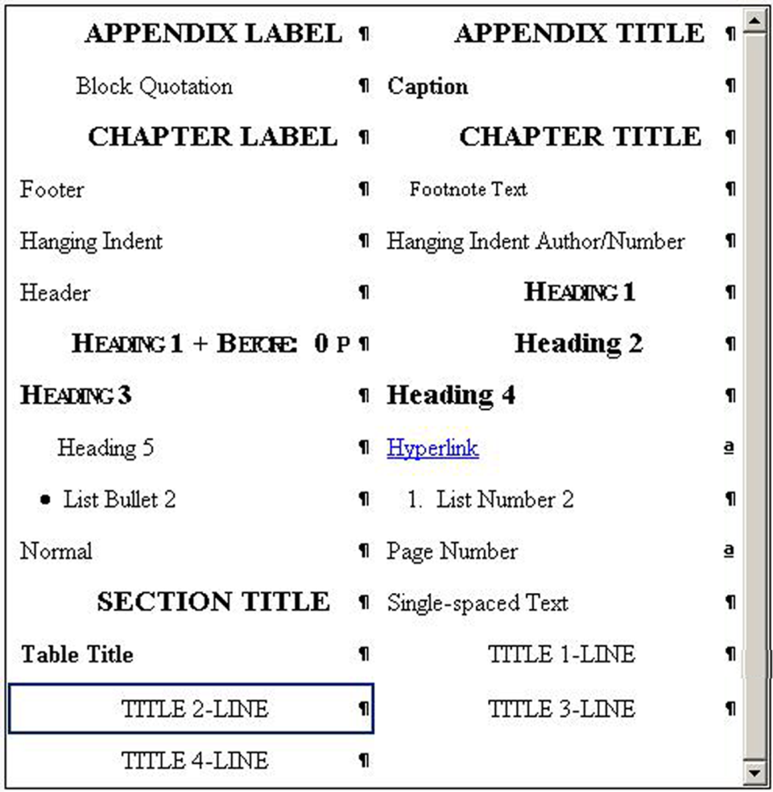
Figure 2. SDSU thesis template styles. Note: The style “Title 2-line” is “boxed” only because the title on the title page was selected at the time this screen shot was taken.
Table 1. Sample of a One-Row Table
Sample Location | # of Samples | Type of Fungi | Relative Humidity, Temperature | Sampling Time
Environmental Chamber | 40 | Aspergillus niger | 50%, 25°C | 3 minutes
Note: Most tables will have more than one row; the purpose here is to show the table title.
this, you must manually end the previous page either 1 or 2 lines earlier (usually not more) to bring that footnote forward to the correct page.
FOR YOUR TEXT, use the pre-formatted heading styles 1-5 as discussed in the DTM. Use the other thesis styles (e.g., those shown in Figure 2) as instructed in the Template User Guide to format other portions of your text (e.g., block quotations, lists, figure captions, table titles, etc.). Remember, you must still read the DTM for additional instructions about editorial style (Sec. 4.9), table & figure formatting and placement in text (Sec. 4.10), and other formatting requirements detailed in Chapters 4 & 5 that could not be incorporated into the template. The template is only a tool that provides most of the technical expertise. The DTM does point out which formatting is included in the template.
Print this document for later reference, then delete all text on pages 1-3 (except for the CHPT 1/INTRO title on p.1). If you are just starting to write your dissertation/thesis, start typing at this point. Or, if your manuscript is already written/partially written, follow the Template User Guide instructions for a specific way to either copy and paste your text into this template, or to identify this template as your master document and insert your files as subdocuments. Most students will need to do the latter as the “copy and paste special” option has limitations.
STOP Delete all text from Chapter 1, p.1 through this text but DO NOT delete the section break below. Keep this section break at the end of your text, before the References page.

references
Insert your source documentation according to your departmental style guide with the exception of single spacing each entry and using normal line spacing between entries. Both versions of the Hanging Indent style (examples shown below) are set up to comply with the DTM requirements. Read the “Reference List” instructions in the Template User Guide and see the DTM, Section 5.2.1.

HANGING INDENT (formatted according to APA here, but you must follow your departmental style).
Kilroy, L. (2005). Dissertation and thesis manual: Policies, procedures, and format (11.1 ed.). San Diego, CA: San Diego State University.
Moll, L. C. (2000). Writing as communication: Creating strategic learning environments for students. Theory into Practice, 25(3), 202-208.

HANGING INDENT AUTHOR/NUMBER (formatted according to IEEE here, but you must follow your departmental style).
[1] S. M. Hemmingen, Soft Science. Saskatoon: University of Saskatchewan Press, 1997.
[56] G. Liu, K.Y. Lee, and H.F. Jordan, “TDM and TWDM de Bruijn networks and shufflenets for optical communications,” IEEE Transactions on Computers, vol. 46, pp. 695-701, June 1997.

STOP Delete the contents of this page (except for the title) and apply the appropriate hanging indent style to your entries. BUT DO NOT delete the section break at the end of this page unless you have no appendices and will also be deleting those pages.

appendix
TITLE OF APPENDIX

Insert your appendix material here. You may title it again or not, as you wish. However, note that if you do, use the PRELIM TITLE style for this title so that it won’t get picked up (i.e., duplicated) when you generate the Table of Contents.

Example of a footnote, its indentation, font size (which can be 2 points smaller than text size), and spacing (single). The second note below has been added to show the spacing between notes.
Example of a second footnote.

